Practice Industry 4.0 with Baowu steel&Siemens to insight China intelligent manufacturing 2025

Speaker: Jiangning Chen
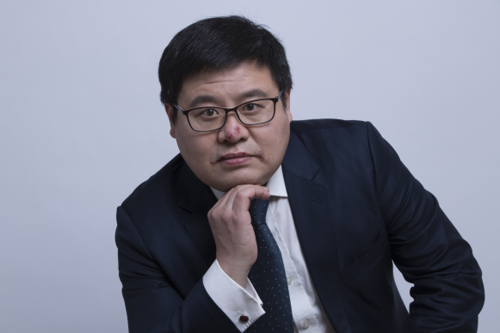

Abstract: Industry 4.0/Intelligent manufacturing is a core to enabler industrial innovation and biz model transform . This talk will present the history, the blue print, the practice of Baowu Steel Group to practice Industry 4.0 with Siemens. In addition, with the demand on Chinese steel industry digitalization, the talk will present those hot topics such as Artificial Intelligence, Big Data, Industrial security, etc. which provides audiences with the roadmap of China intelligent manufacturing from a practical perspective.

China Baowu Steel Group Corp., Ltd., is a state-owned iron and steel company. Its production volume is the second highest in the world (34.938 million + 25.776 million), after ArcelorMittal (97.136 million in 2015).

Biography
Mr. Chen Jiang Ning is the head of Baosteel & Siemens Go to Industry 4.0 Project (Metal) in Siemens Corporation Technology. In the past, he was GM System integrator management in DF&PD division, Siemens and head of sales excellence, Verticals sales in DF&PD division, Siemens and section manager of Industry Identification in in Industry Siemens ( IoT, RFID , Machine version ), GM of IRM group in China and project Manager in LAP laser German and project Manager in Baosteel Group. He has published many scientific articles in the field of automation and sensor. He holds more than five patents in digital factory. He is a fellow and member of the following associations such as fellow of academy committee of CCID, China Intelligent manufacturing System integrator Alliance, and China Intelligent manufacturing standard.

